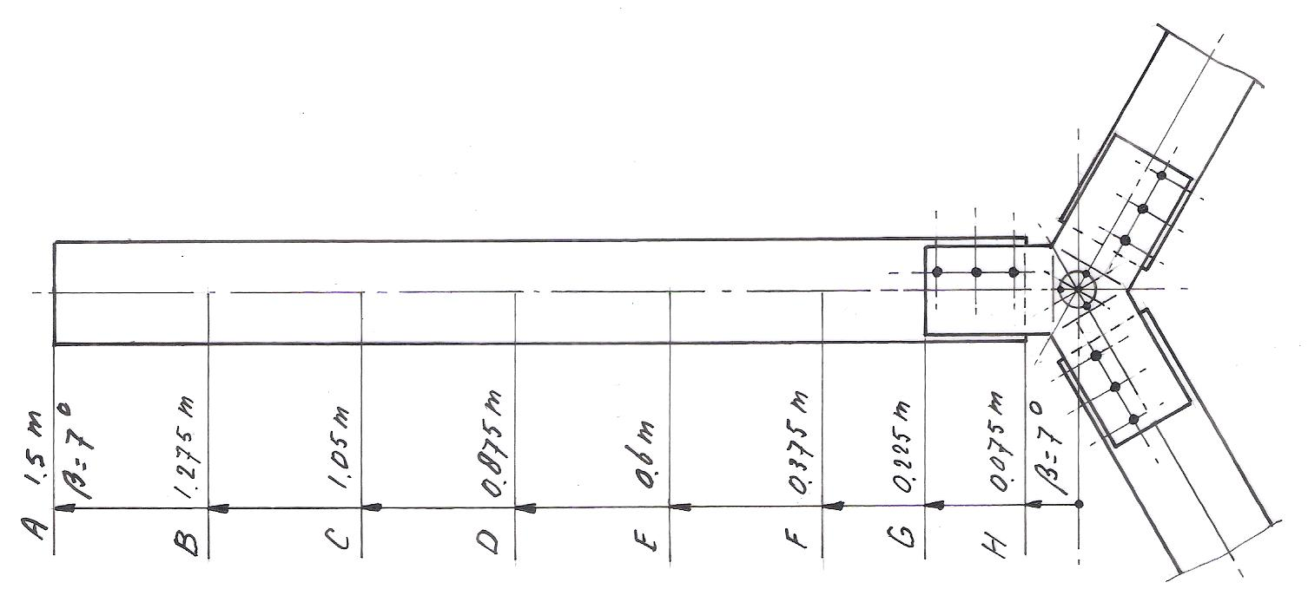
Rotor VIRYA-3B3

rotor diameter: D = 3 m
design tip speed ratio: λ_{d} = 6.5
number of blades: B = 3
chord: c = 150 mm
blade angle: β = 7°
airfoil: Götingen 623
direction of rotation: right hand
material blades: hard wood
coating blades: two layers epoxy, two layers aluminium paint
material hub plate: stainless steel AISI 304
For design calculations of this rotor see public report KD 484. This report can be copied for free from my website: www.kdwindturbines.nl at the menu KD-reports.

